2019-2020
VIQC Squared Away

工程筆記 Engineering Notes
Pro. Dish Soap0.0 86761B

Members:
Alan 賴冠澐
David 徐大鈞
Bowei 黃柏崴
Teachers:
Eric 陳麒宸
Harvey 牛彥如
目錄 Table of Conetent
起初想法 First Ideas 3
結論 15
紀錄 17
第一版 (圖片已損毀)
第二版 17
第三版


https://laiabc8660.wixsite.com/mysite-1

起初想法
First Ideas
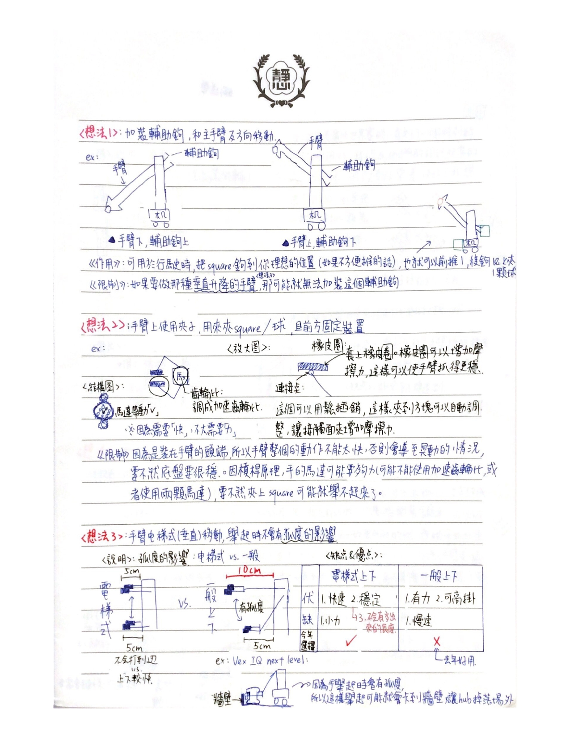
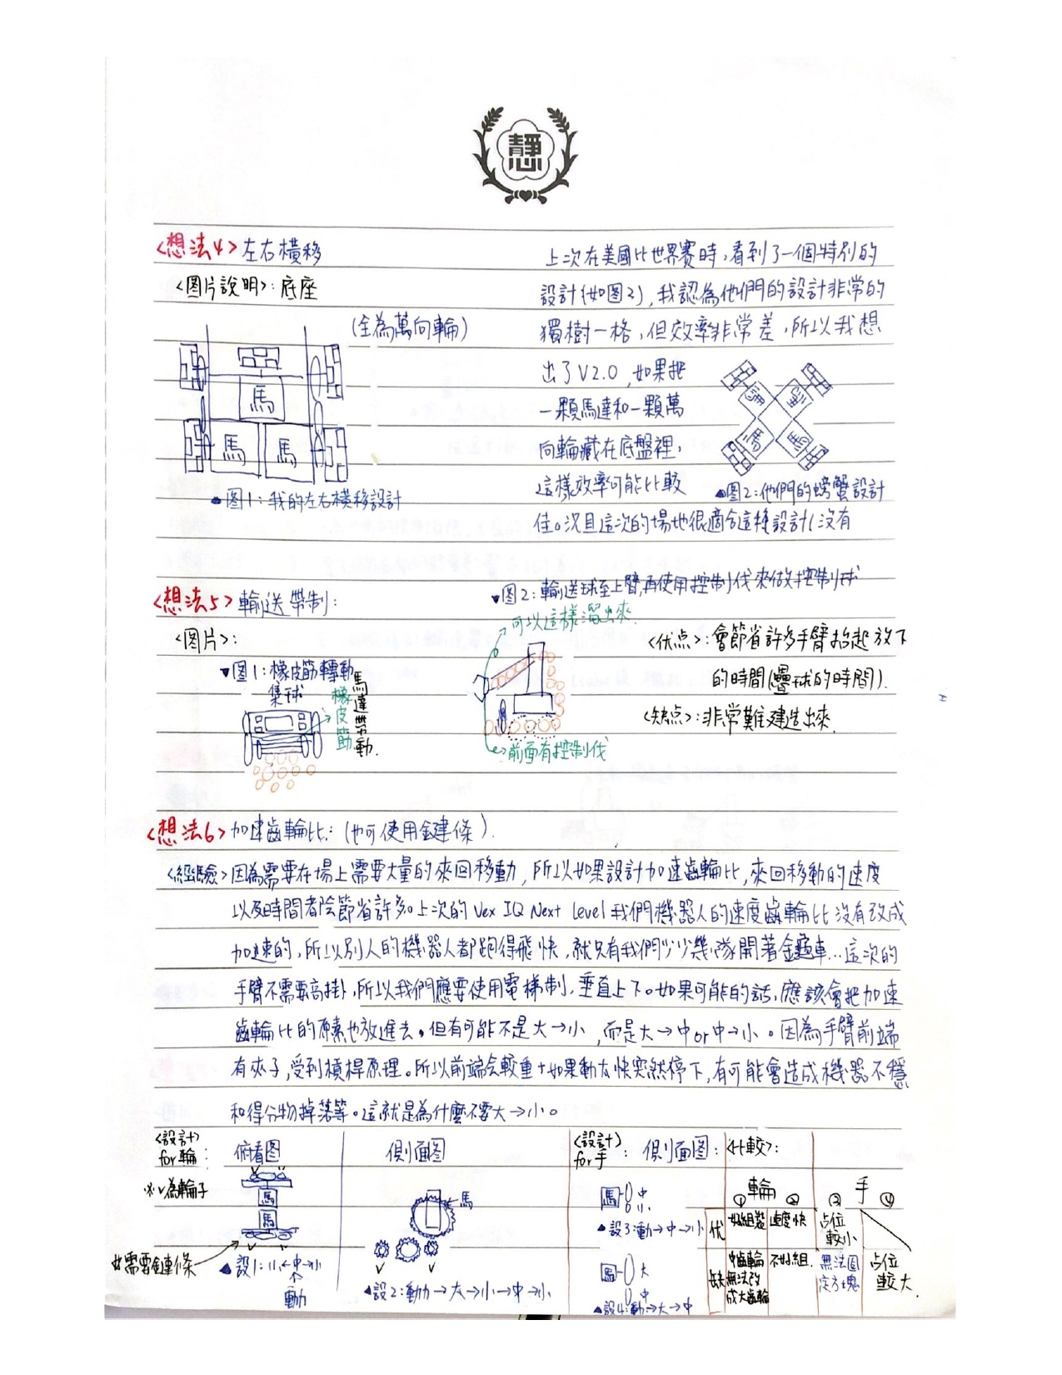
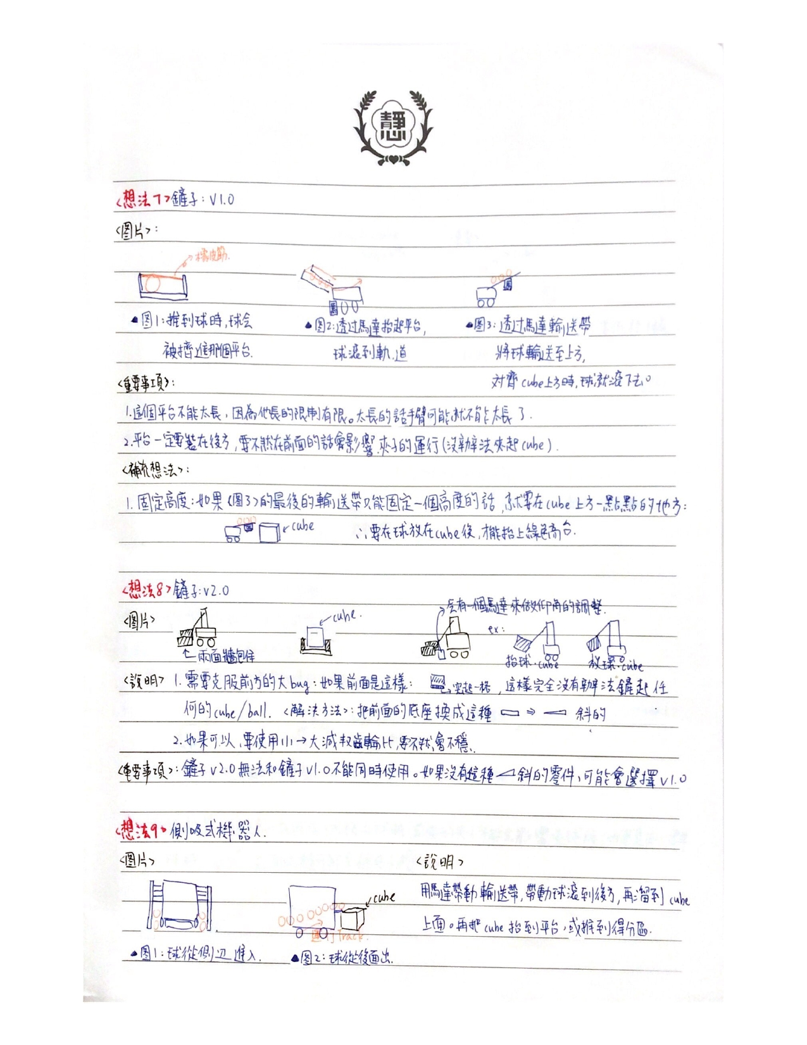
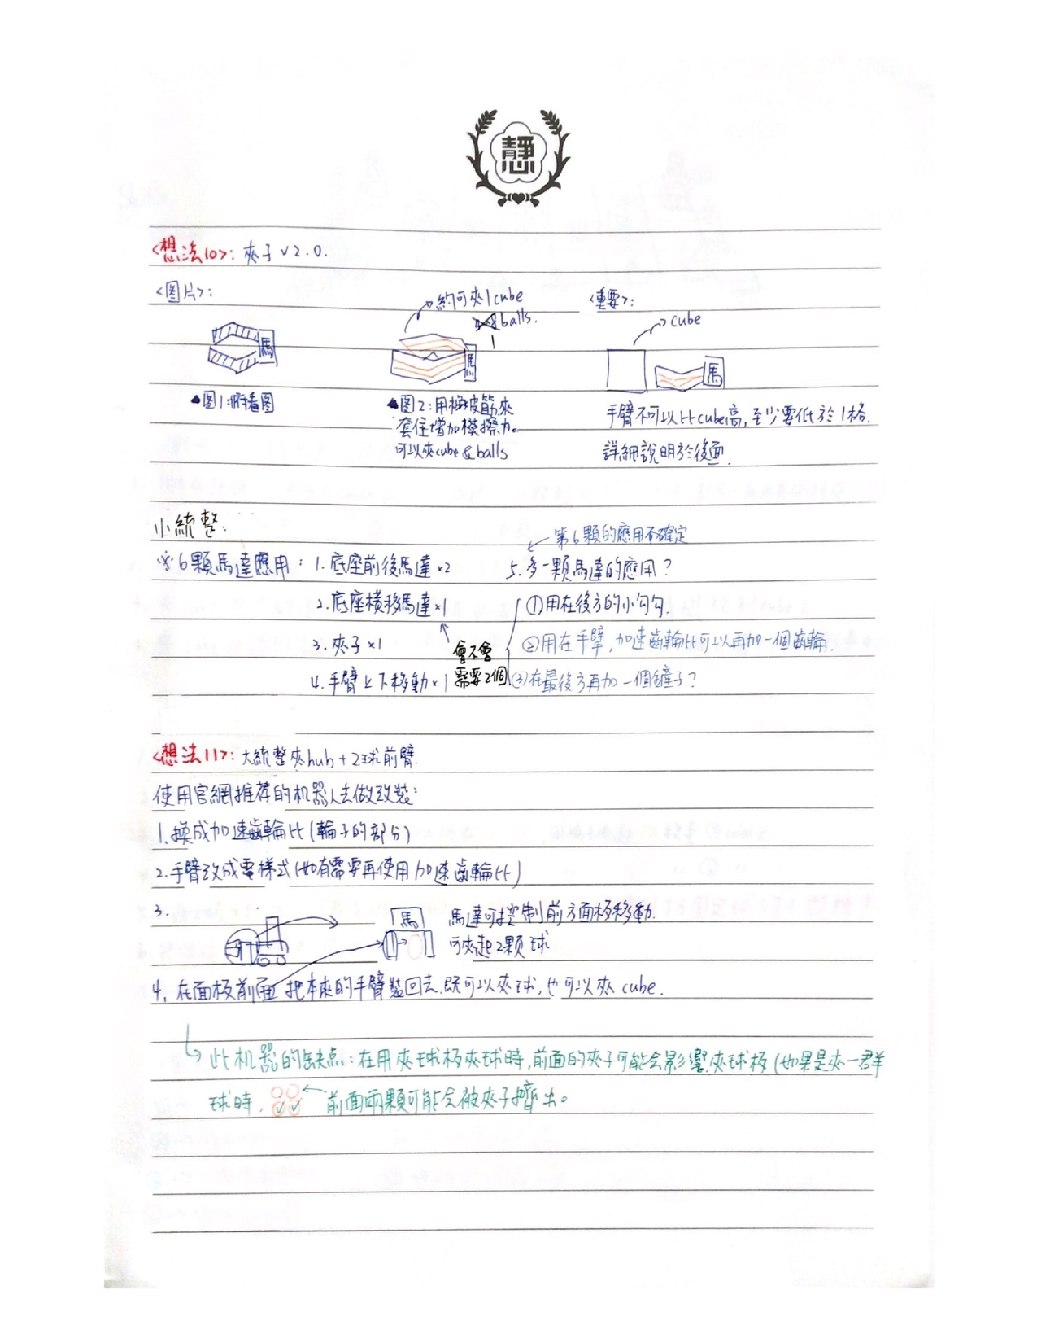
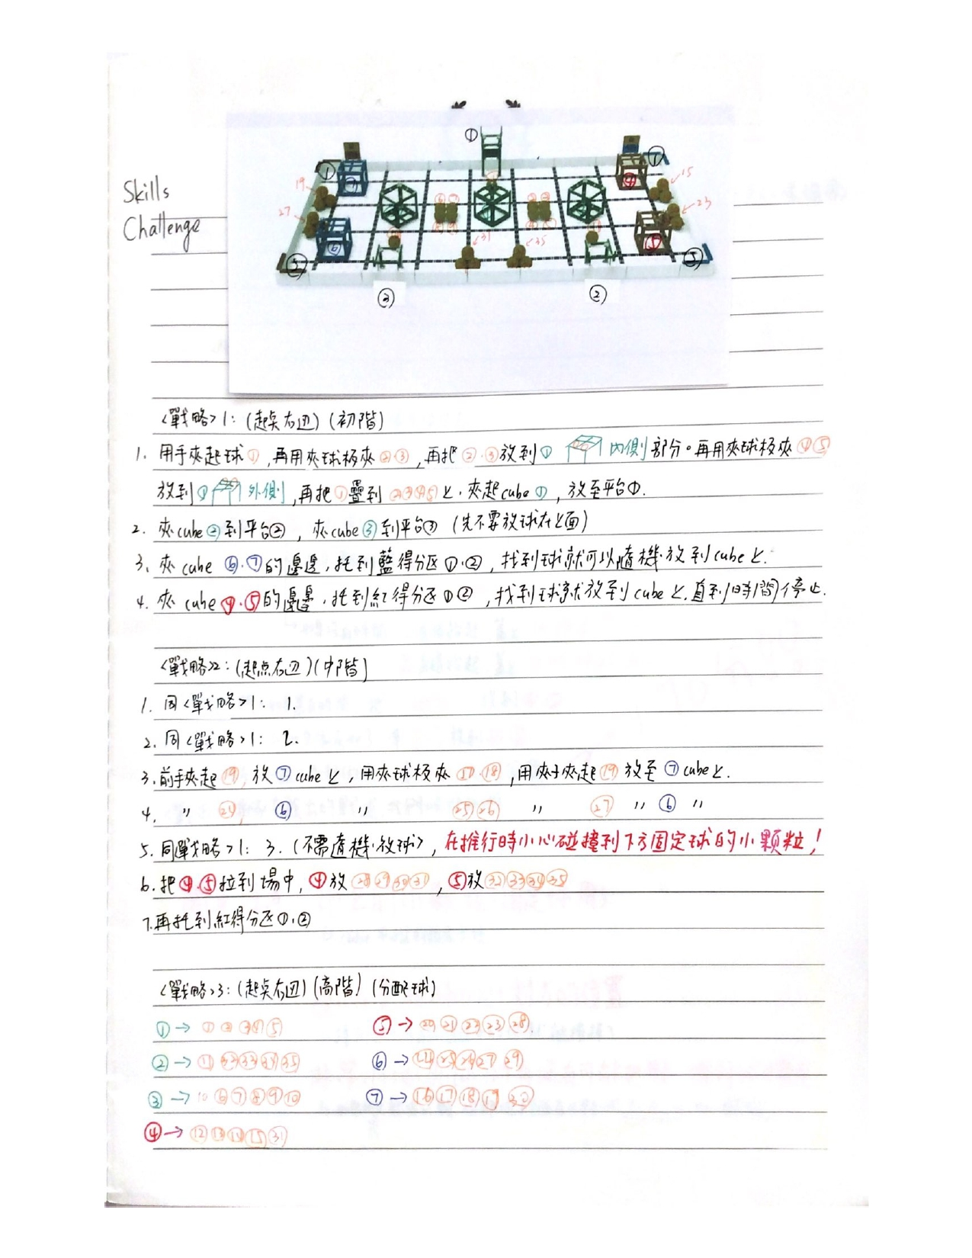
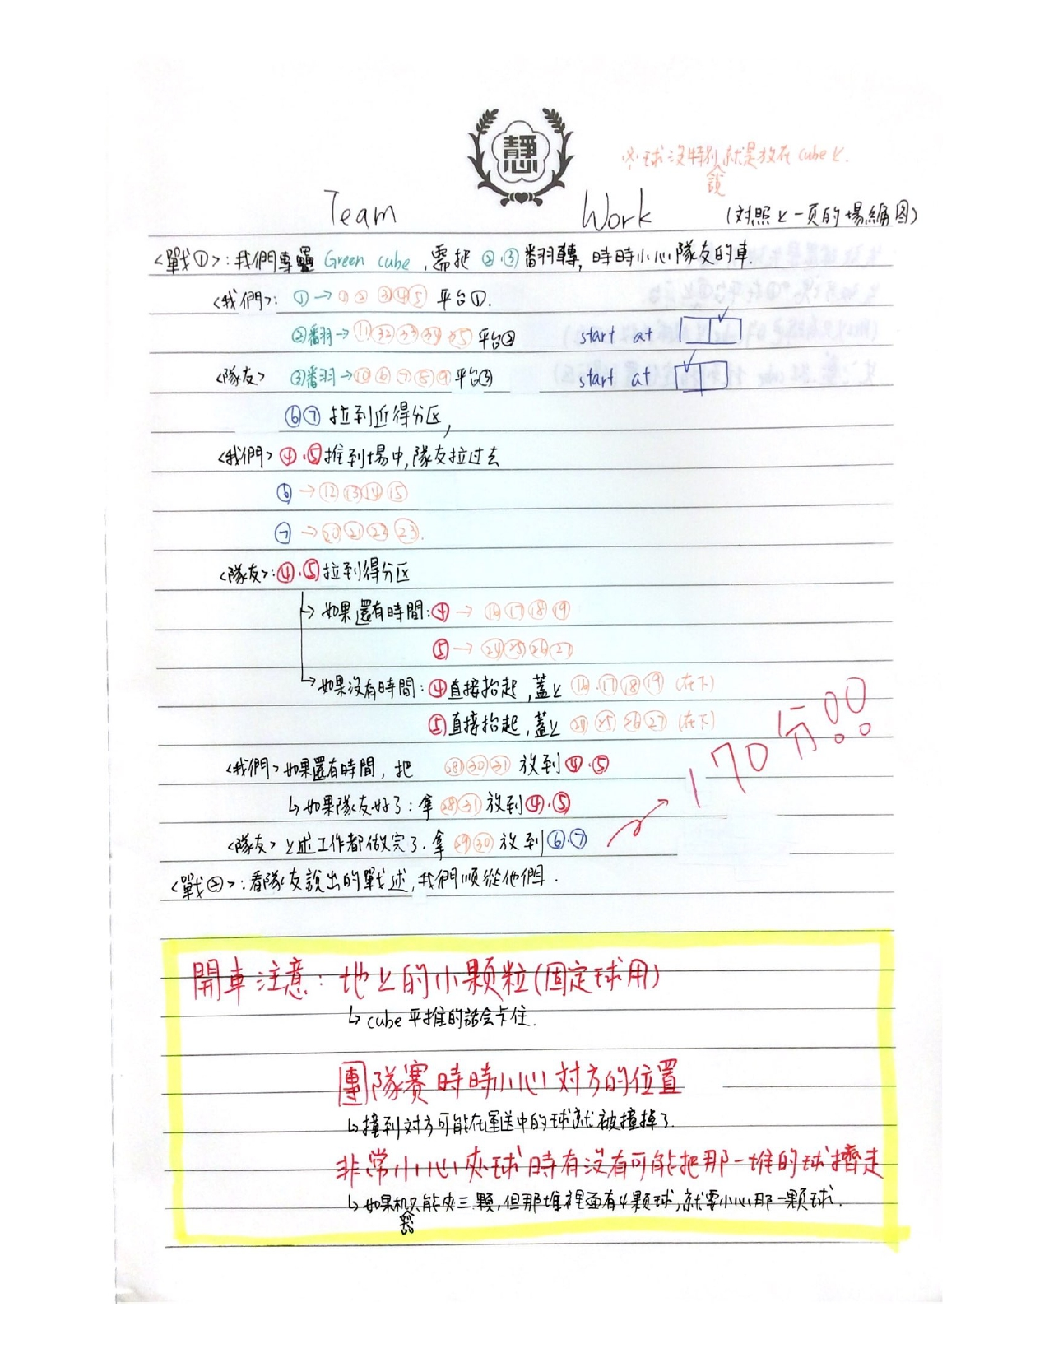
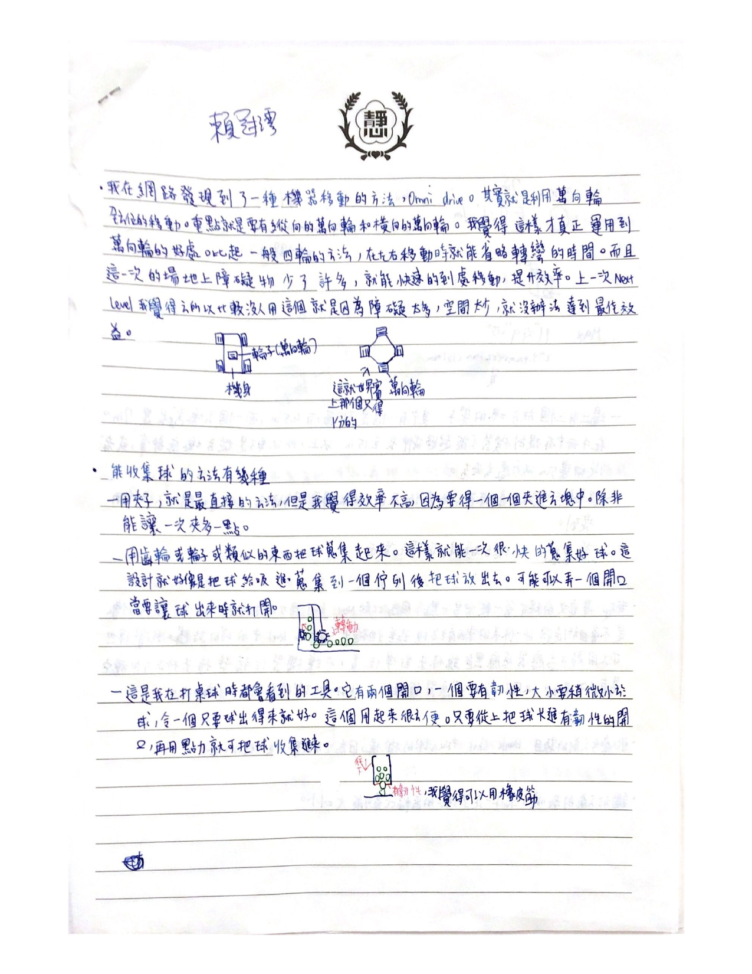
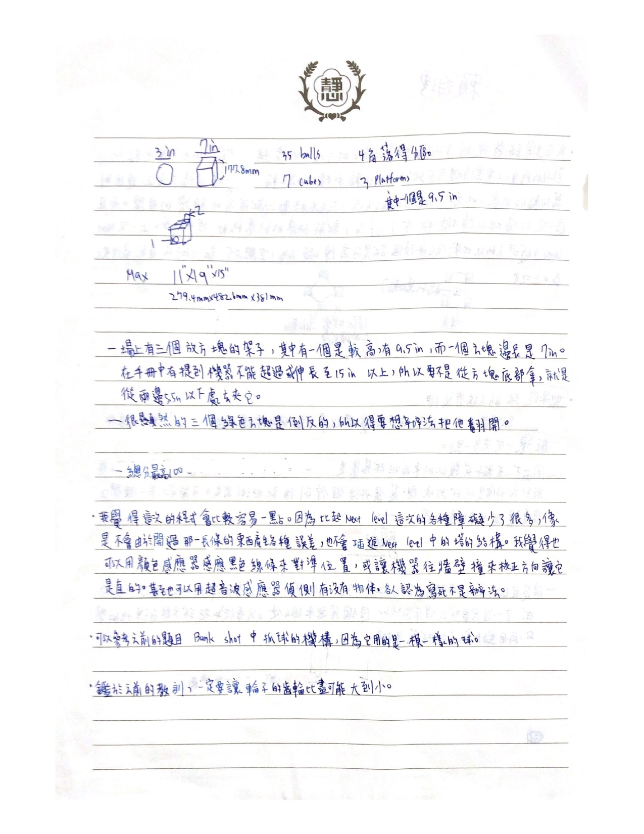
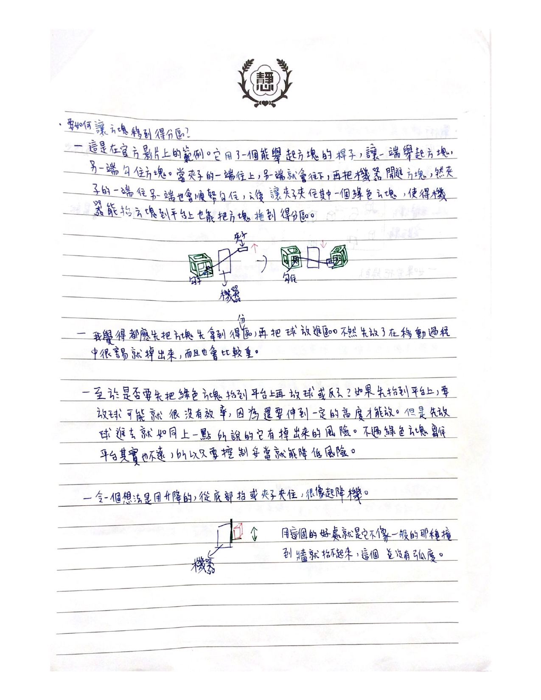
徐大均記錄(我們一開始的想法)
- Basic Design
In this season’s challenge, if teams want to get scores as high as possible, there are two necessary functions. First, the ability to carry cubes. Second, the capability to collect balls.
- Version 1 of Design (good start)
Discussing about how it is possible to put two functions in a single robot, the first idea that came to our mind was to put two claws that are connected with a bar, and control their vertical position with a motor.
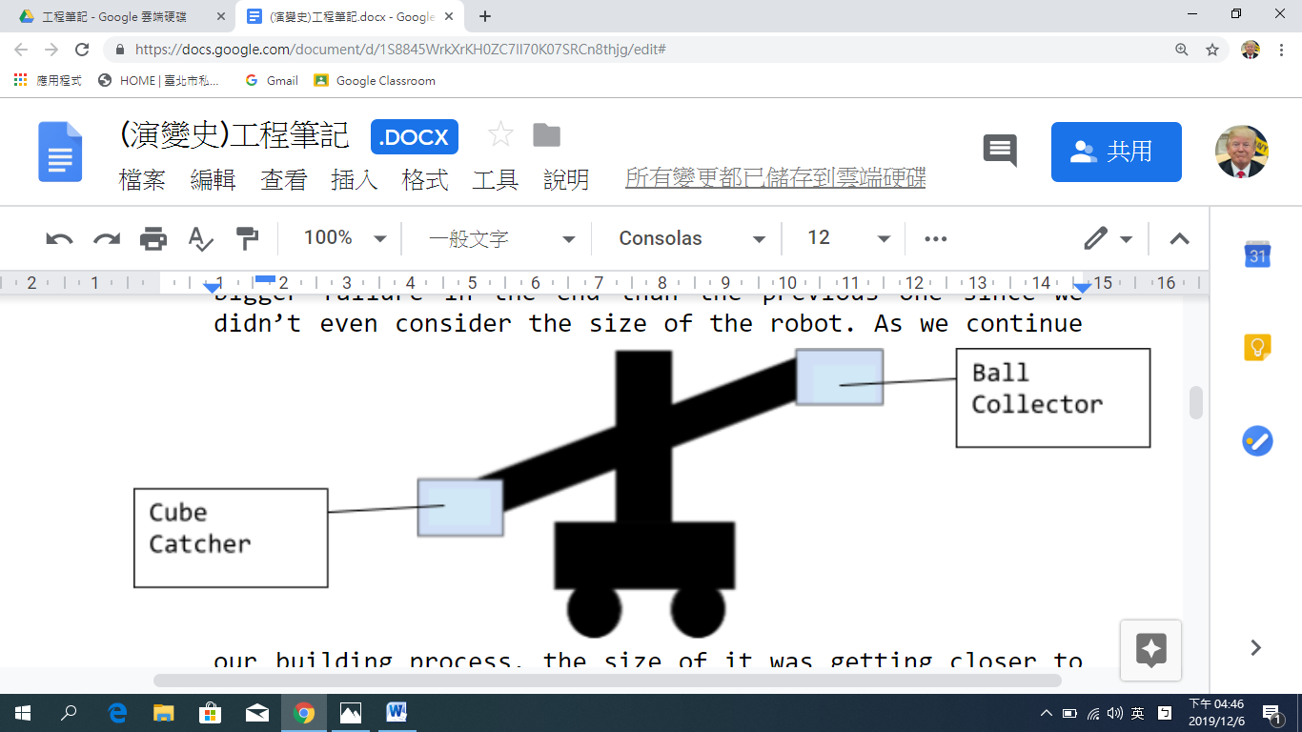
Yet as soon as we started our build, we found out two problems. First, even if we use as few motors as we can, the structure of the robot still requires over the maximum amount we can use (6 motors). Second, the ball collector “claw” won’t provide us the chance to get as many points as possible because it can only carry up to a maximum of two balls at a time. Thus, we changed the design thoroughly.
- Version 2 of Design (enormous failure)
In this design, because of the previous failure on the ball collector, we decided to ignore the ball-collecting function temporally and focus on cube catching. Therefore, we designed a claw for the function. However, it was even a bigger failure in the end than the previous one since we didn’t even consider the size of the robot. As we continue our building process, the size of it was getting closer to the limit, and we didn’t discover. Thus, when the teacher reminded us about the limitation problem, it was too late. The only way is to rebuild the whole robot. Meantime, we had the chance to rethink about the ball system, which we later came out with a great idea.
- Version 3 of Design
Reminiscing back to the first design, we originally wanted to have a ball-collecting system on the robot. Yet the way we design and build it was wrong. It was only a claw, which cannot carry enough balls at a time. Thus, we referred back to the 2015-2016 Vex IQ challenge – Bank Shot. Similarly, the challenge has the requirement to collect and keep as many balls as possible. During that season, most teams used 2x4 beams attached to chains in order to collect balls. In the part of keeping, teams often use a large space to store them. Citing the idea, we collect and keep balls in the same way, while building a blank area under the storage area to put the cube, waiting to be filled with four balls on the top. At the bottom of the storage area, we left two rectangle holes for the balls to fall, and connect pitch standoffs and center lock beams in order to block the balls. When the blocking bars are turned away, four balls fall on the top of the cube.
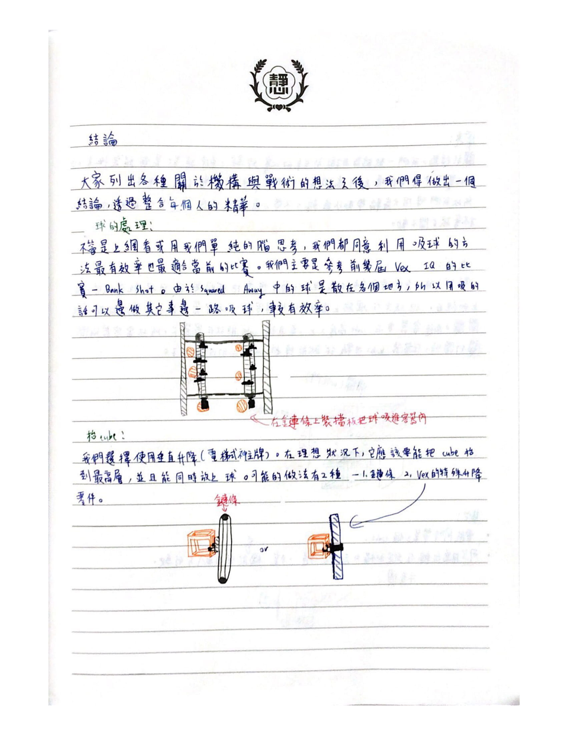
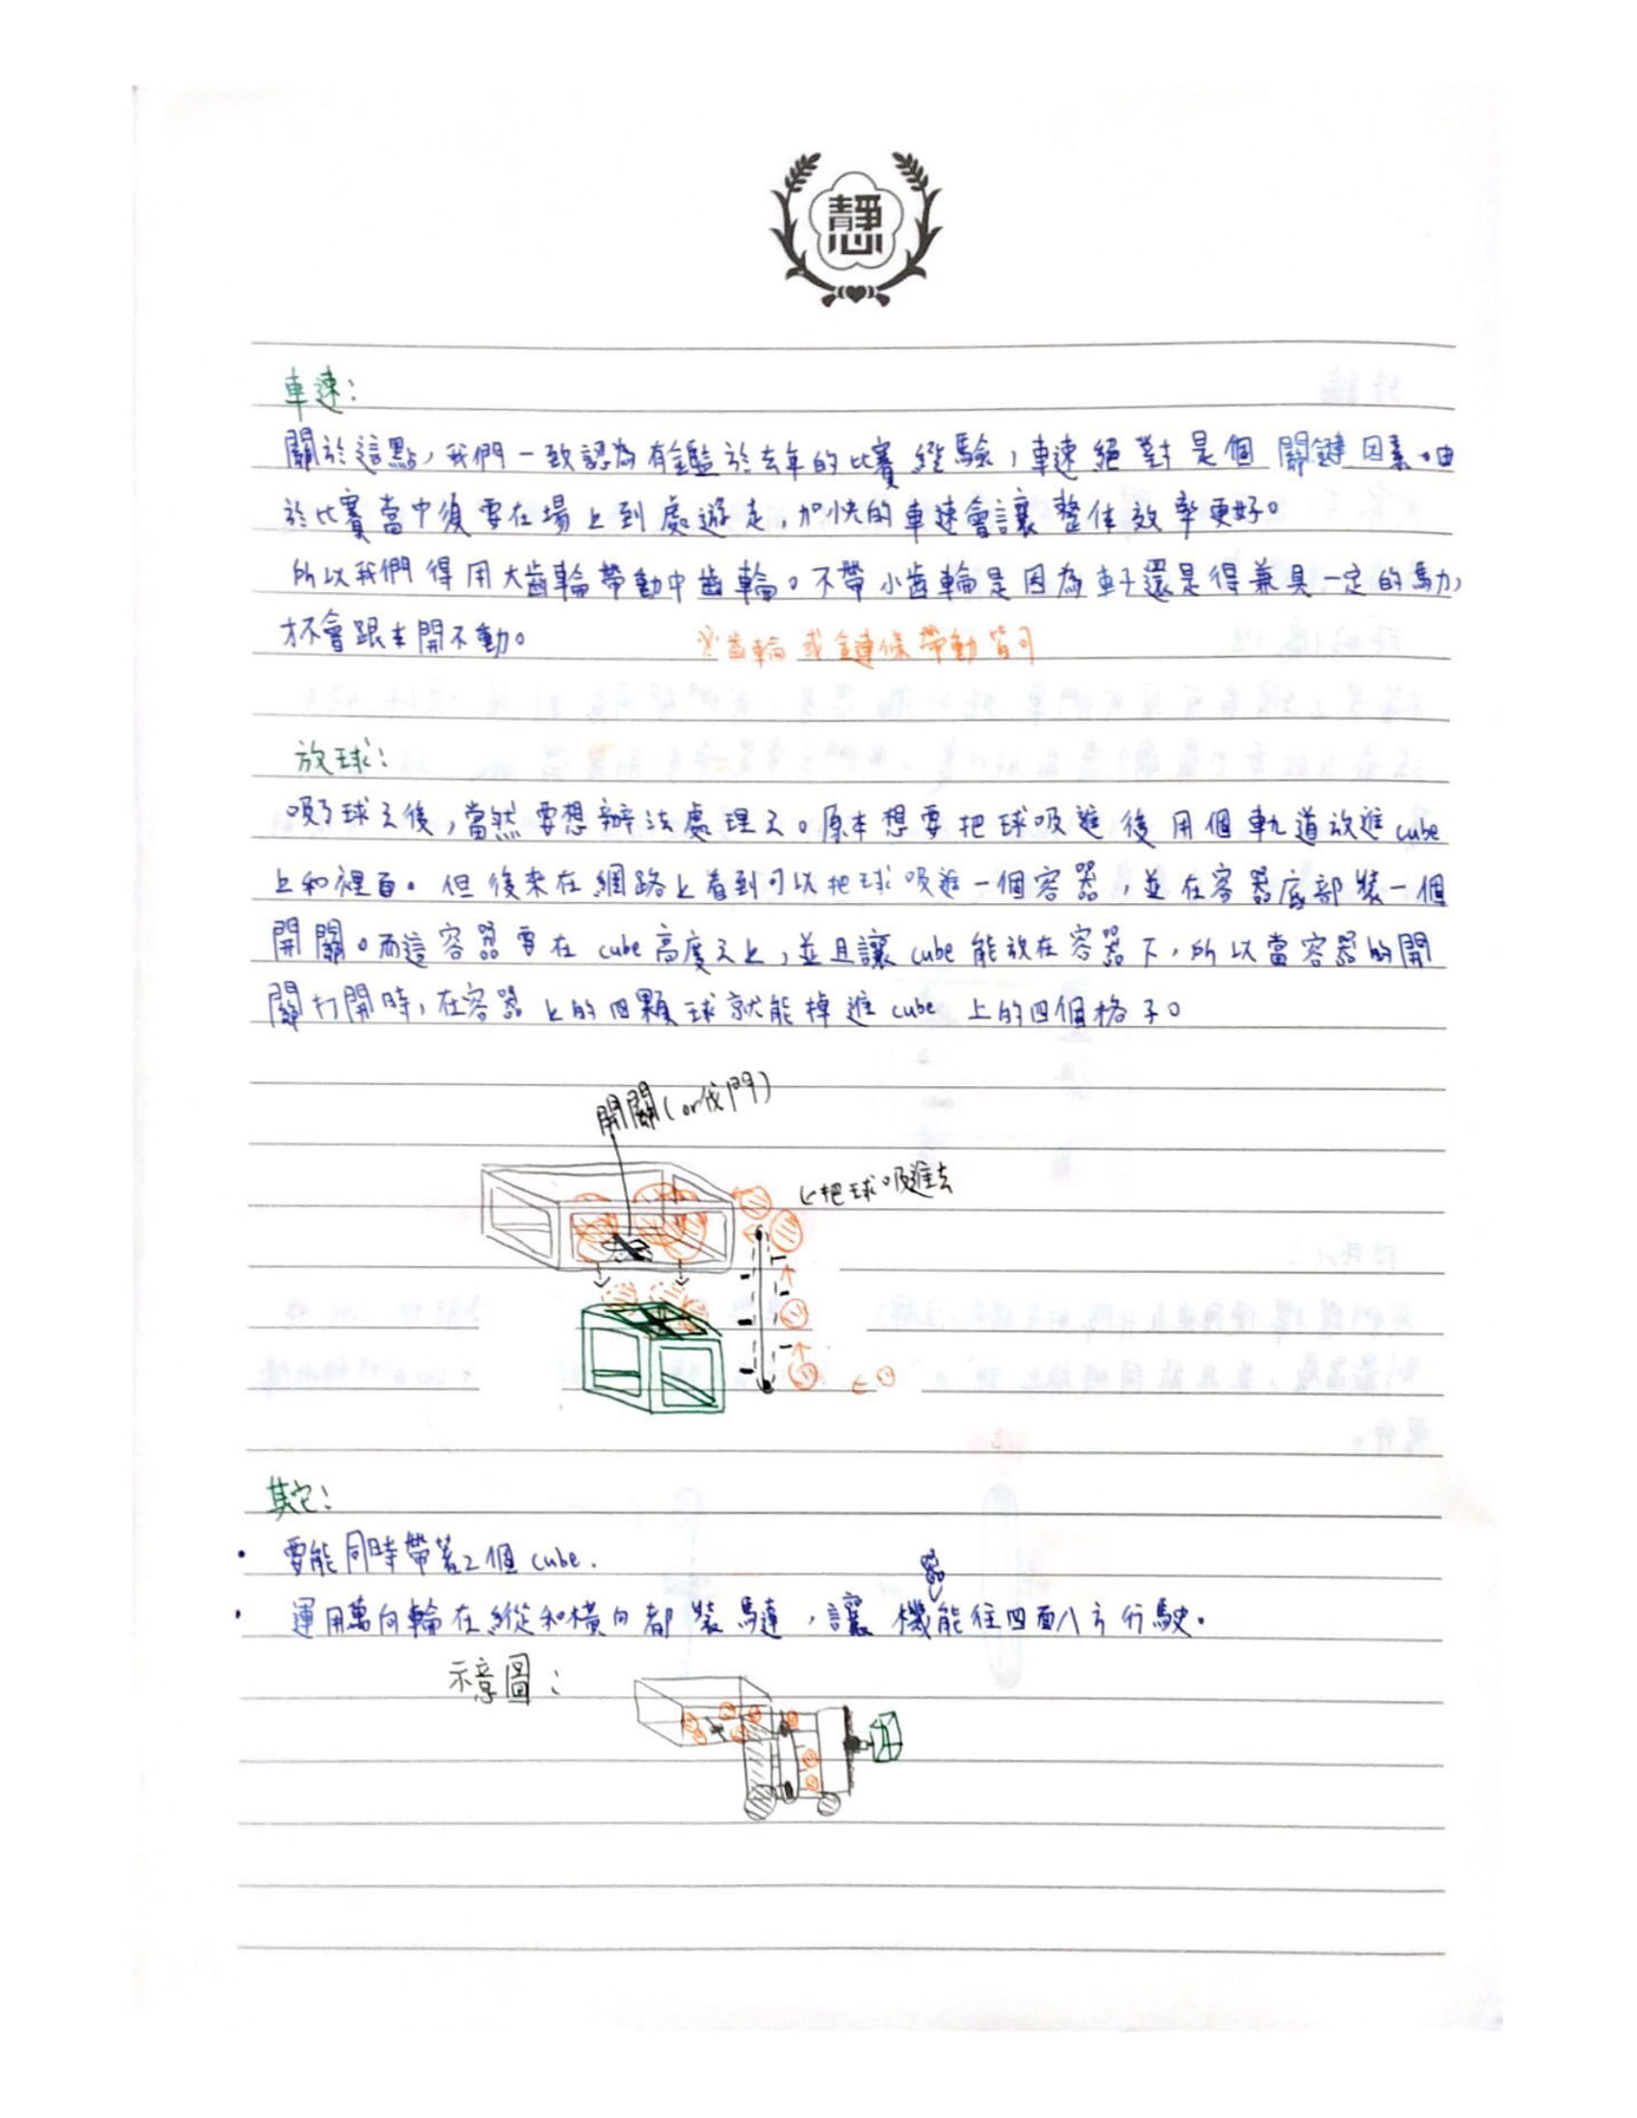
上一版的機器由於有點搞砸，所以我們決定拆掉重做。
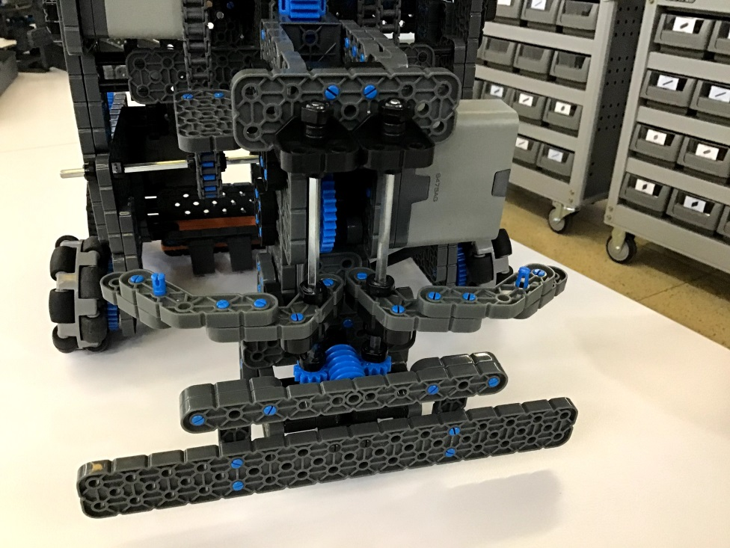
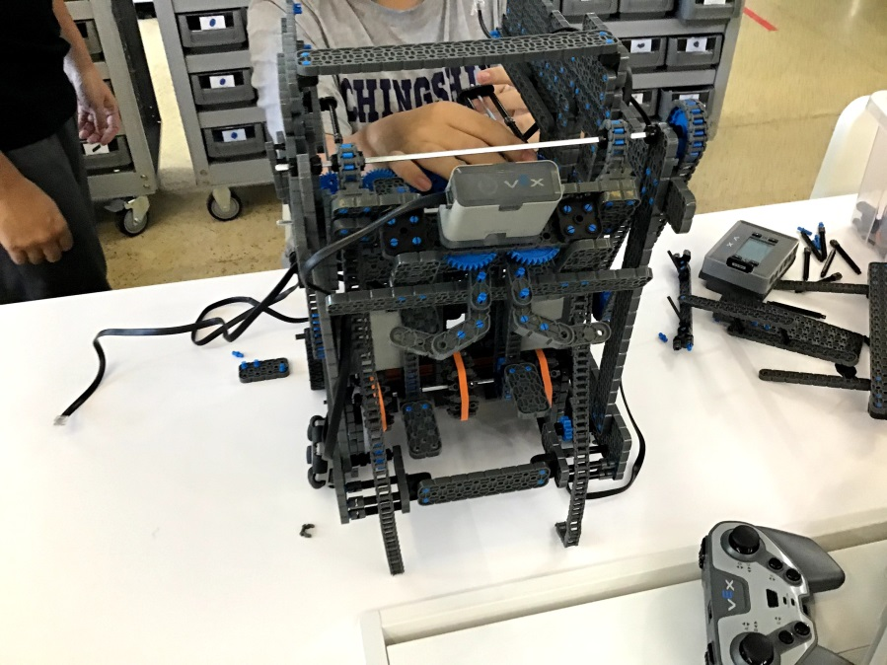
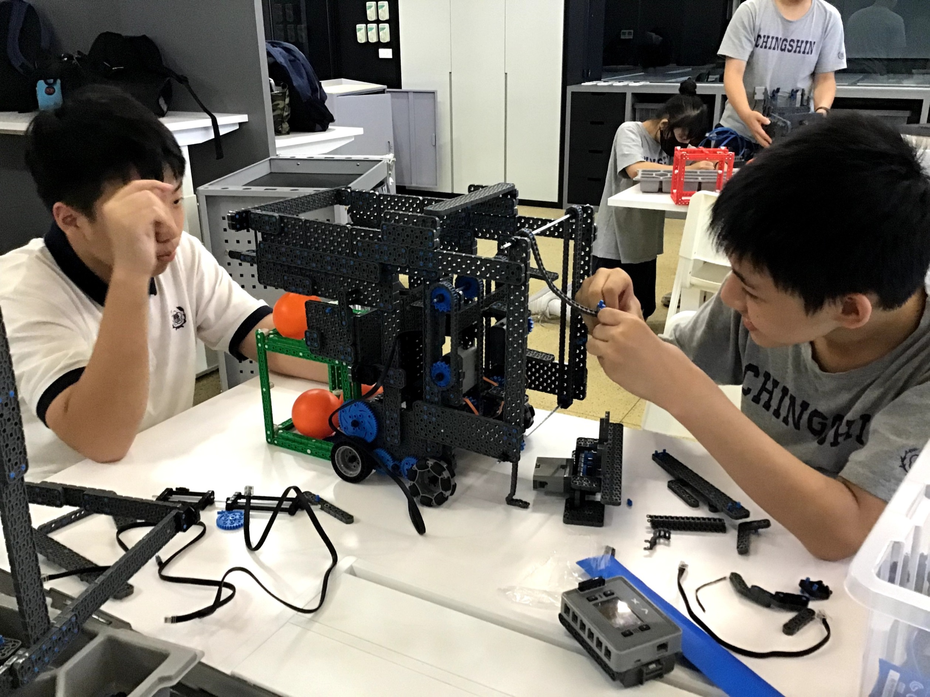
大帶小的齒輪比
但是後來改會相同的齒輪比，因為這種的齒輪比實在無法負荷機體的重量。
垂直抬cube(後來一直無法抬到最上層，所以在下一版改掉了)
第二版(8-10月) *第一版的圖片已損毀
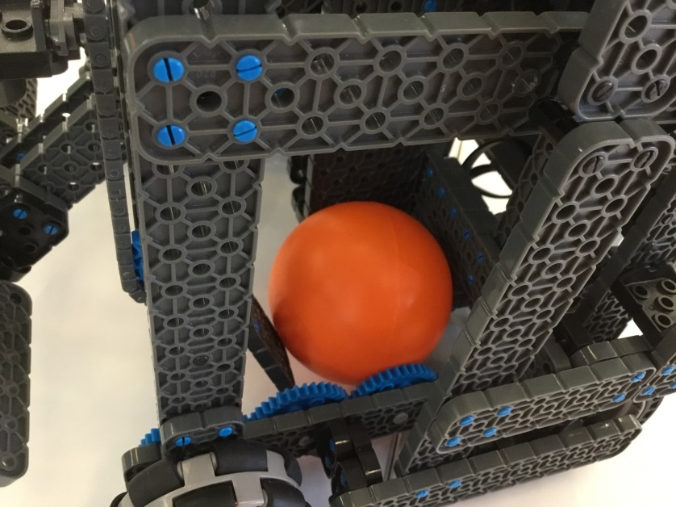
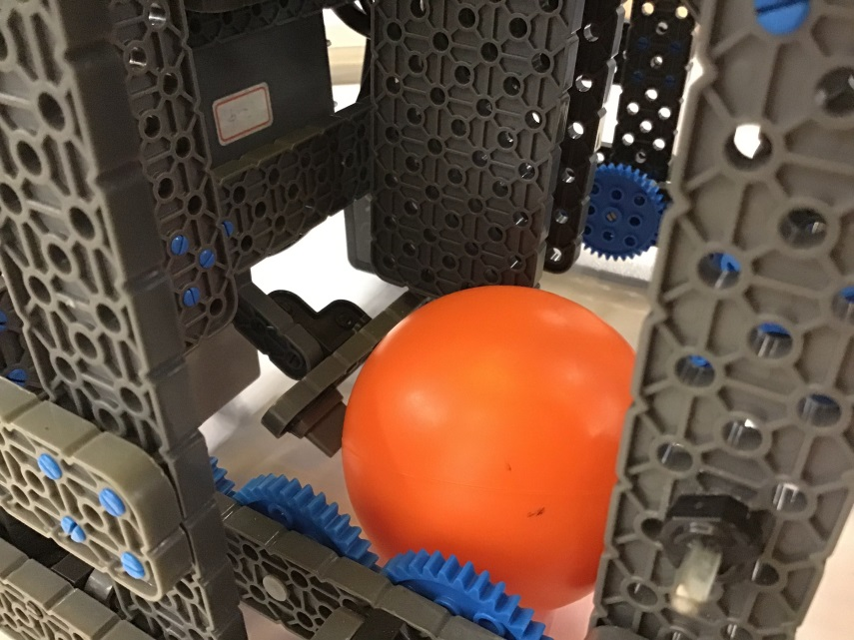
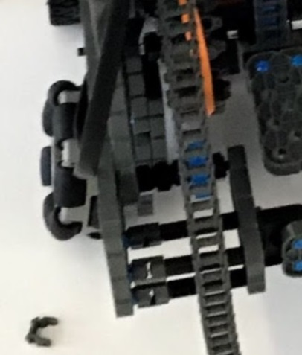
馬達持續運轉中
第一台的機器人我們把輪子放在最外圍，中間為了要吸球，所以把中間空出了一個很大的位置。但我們都把上面的架構都做好了，接上電線，推搖桿時才發現：跑不動！
原因有：
- 整體太重(包了太多不需要的部件)
- 齒輪比是加速齒輪比，馬力因此降低很多。
- 我們的輪子裝得太外面+機器太重，導致輪子外八情形。
所以總結來說：我們的機器太重了！

我們組裡面和老師們討論了很久，決定放棄這一台機器，再重新組一台機器。

吸球設計上，如果吸進時只用一個垂直檔板，球會被卡住不動，所以我們用了彎曲的L型零件做出一個斜坡，這樣球才能順利地滑上去。
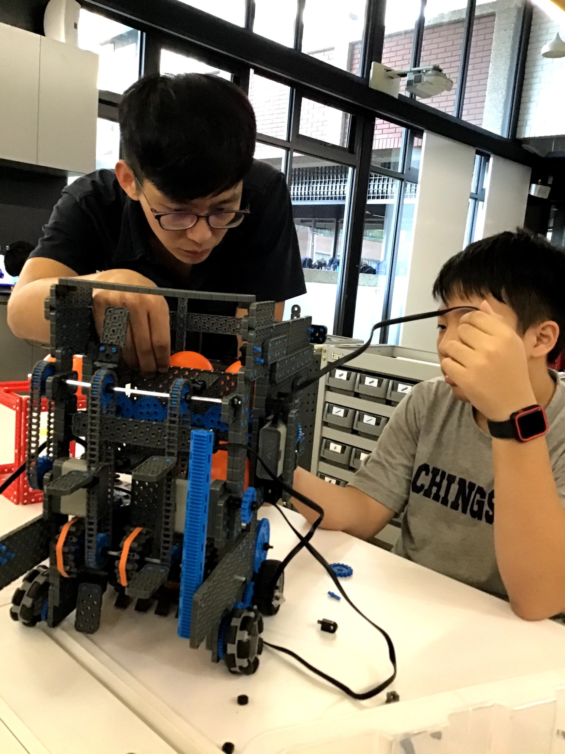
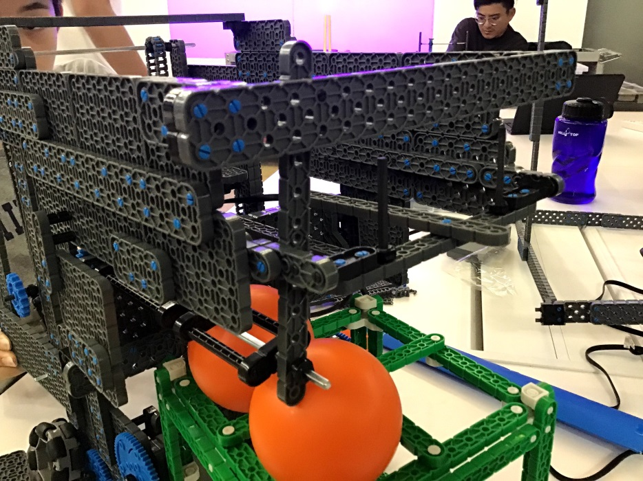
放球裝置—容器底部有個開關，球可以在開啟時剛好掉進cube上的四個洞。那開關有做成一點的斜下去，所以球在吸上去後會自動往後填補。
吸球裝置
球吸進後會到放球的容器內。

雖然上一版已經是接近理想的機器，但是由於機器的各種功能都是一個一個地加上去又改來改去，沒有好的規劃，所以導致作後整台太重，衍伸很多問題。
所以我們決定重新裝一台。這一版我們保留了上一版的功能，但是加以改進。
手臂—因為我們覺得要垂直台cube到第二層不太可能，而能抬到第二層又很重要，所以我們決定改成最普通的手臂(如圖)，就算得犧牲掉把球放上cube的分數(只有第二層)。
第三版(10月-現在)

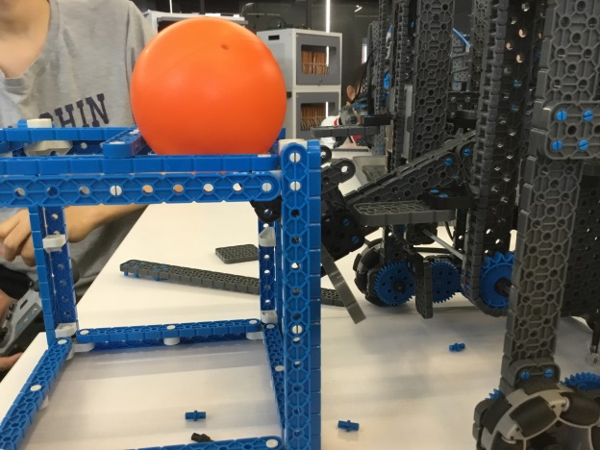
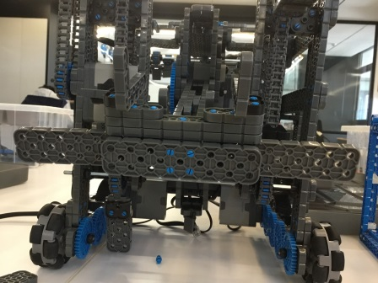
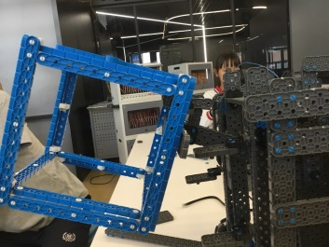
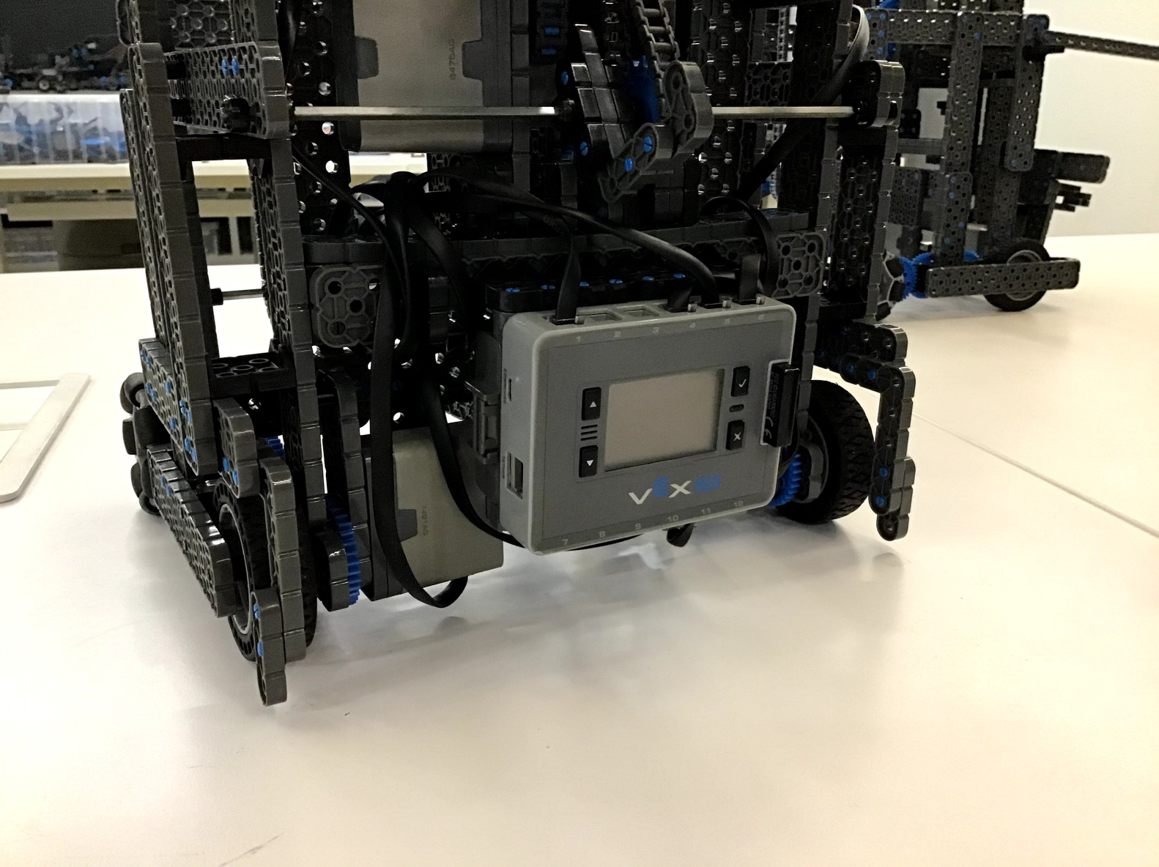
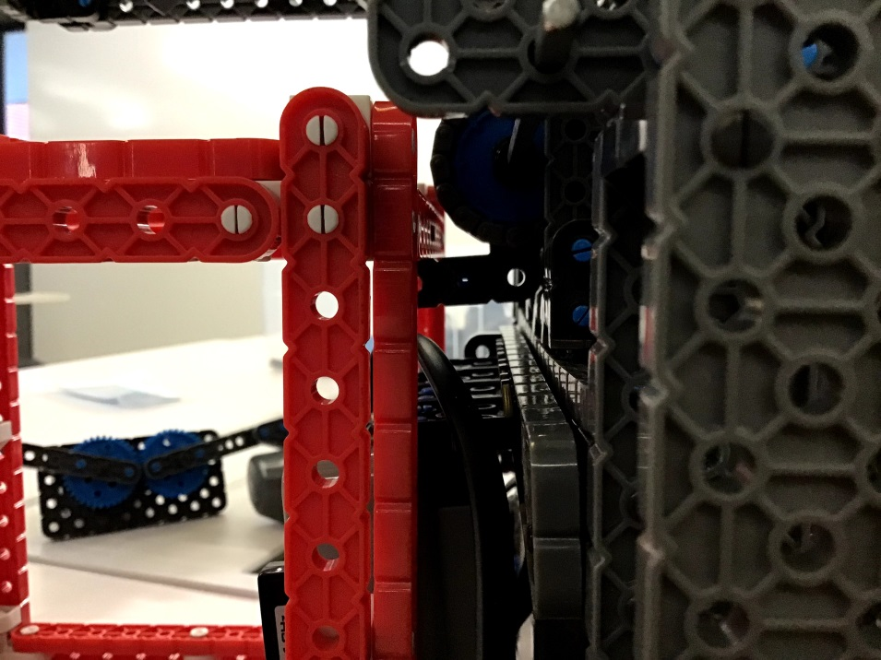
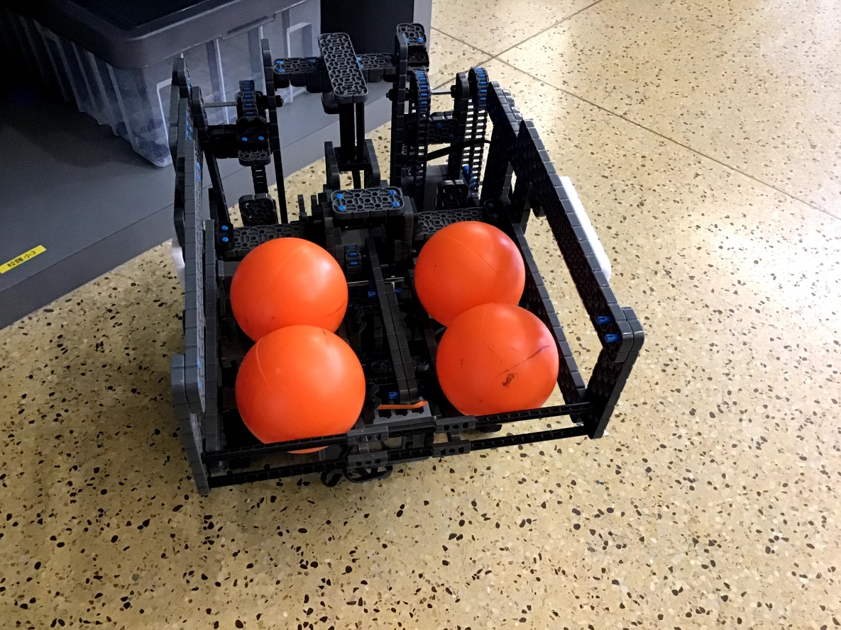
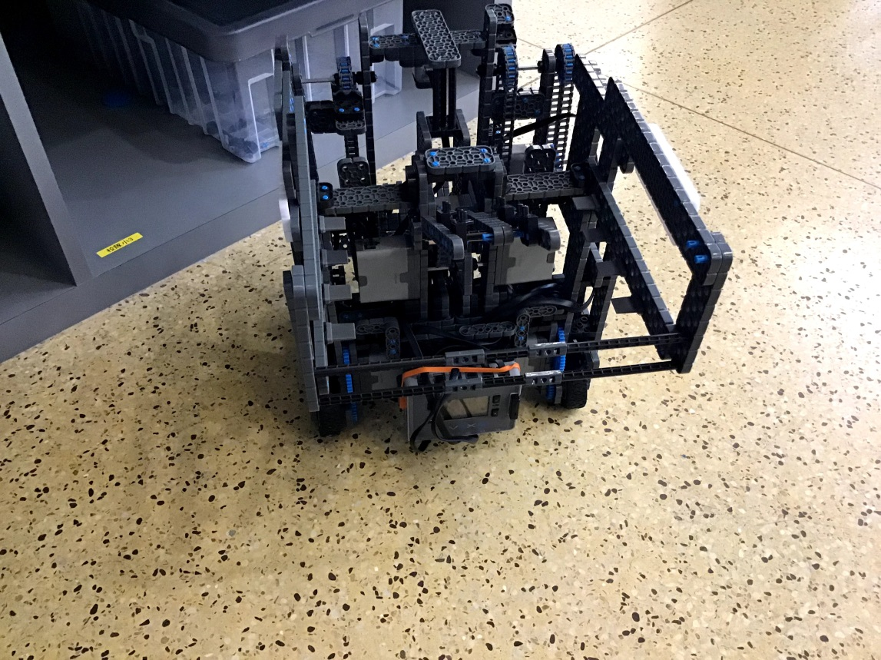
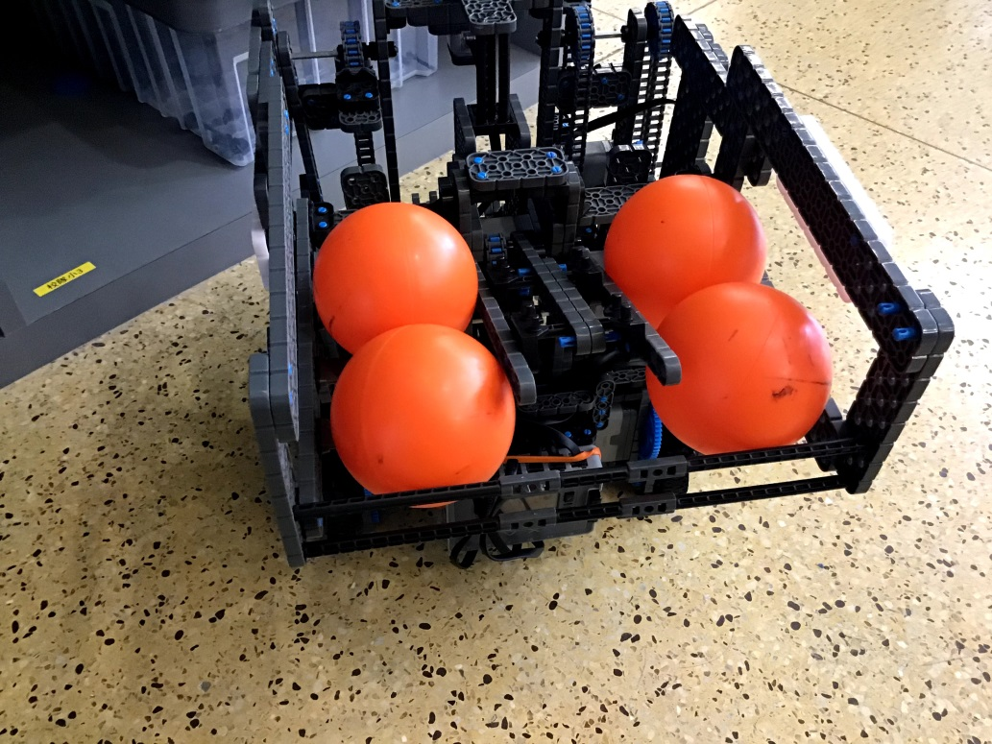
後面有個鉤子可以把cube抓起來，這樣一來我們就能前後同時抬cube在場上遊走。
我們還改了原本的放球裝置的設計。這個版本的開關是會往上抬讓球被擠下去，最終掉進cube的四個凹槽上。而且也一樣開關再關起時是斜下來，這樣球吸上後才會自動往後填補。

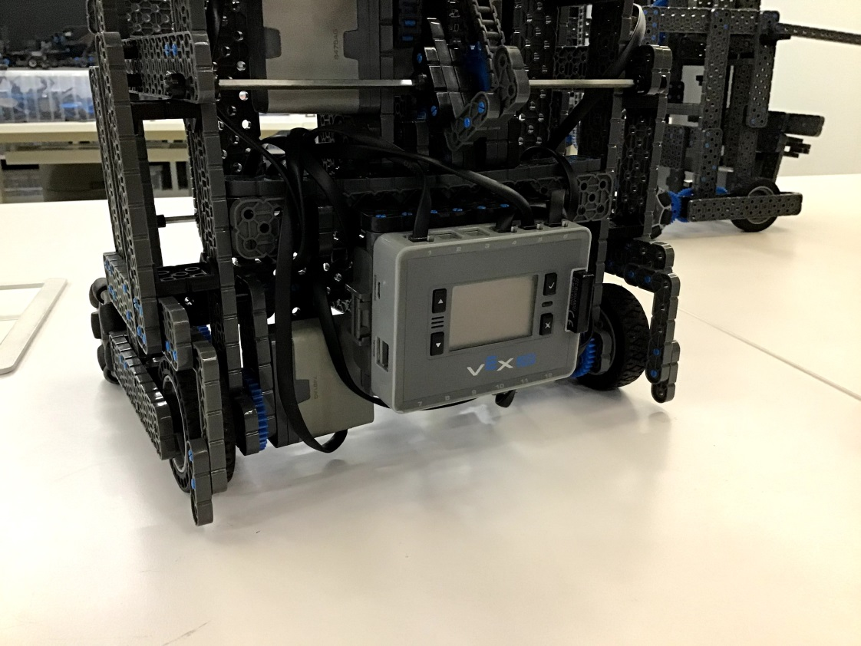
大帶小齒輪的回歸—這次我們有控管好重量，所以還算跑得動，而且很快。
這次對於輪子有做更穩固的設計，主要目標是防外八與快齒輪比。

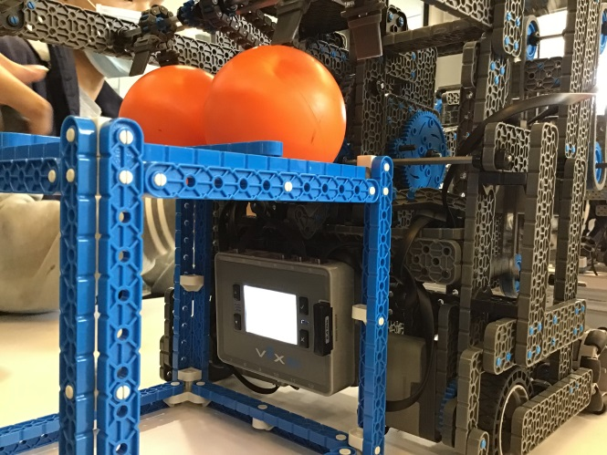
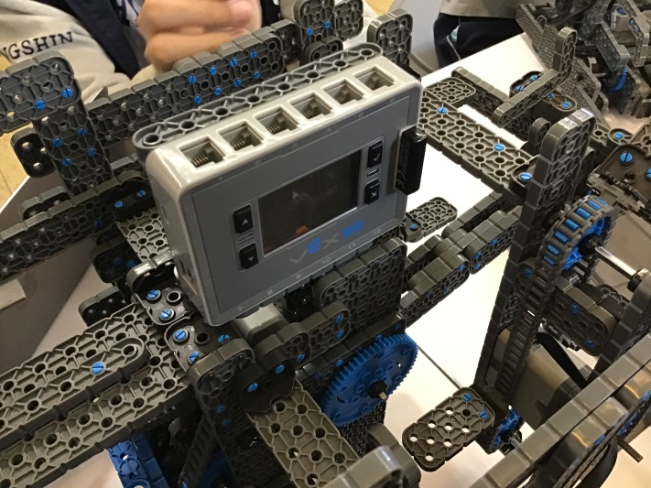
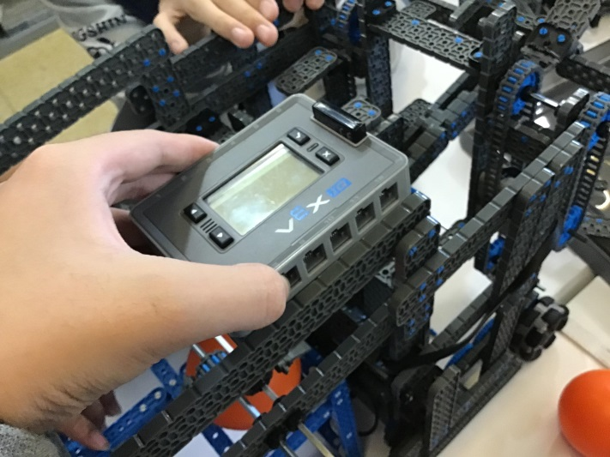
主機沒位置放的困境---

我們是過兩種，但右圖第一章會使主機下方接孔被擋住，而第二張的裝法會擋住球進去容器內。

最後我們選擇裝在後方的下面，如下圖所示。這樣剛好可以裝進cube的方框中，不會有任何引響。

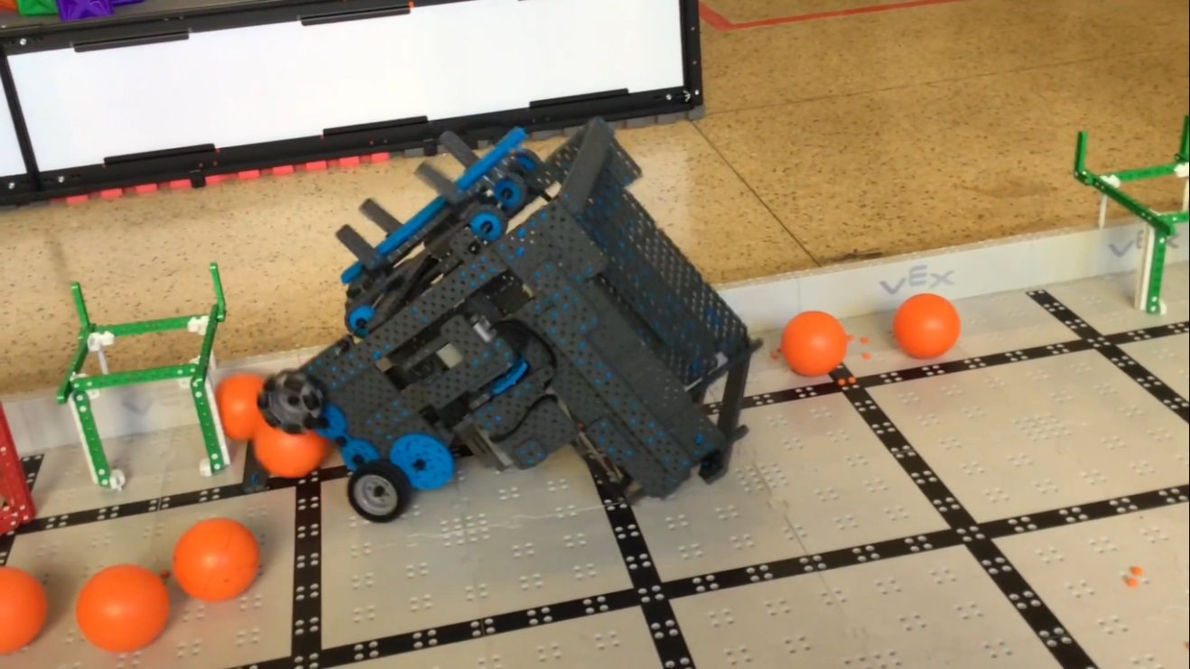
由於我們的主機裝在機器的最後方，所以機器的重心都在後面，如果開一開撞到東西，一定會往後翻。(下圖是雖第二版的機器，但它亦有此問題)

所以加了兩根東西，來讓車子即使要翻覆了，也可以支撐住，使它依舊維持正立。

Before | After
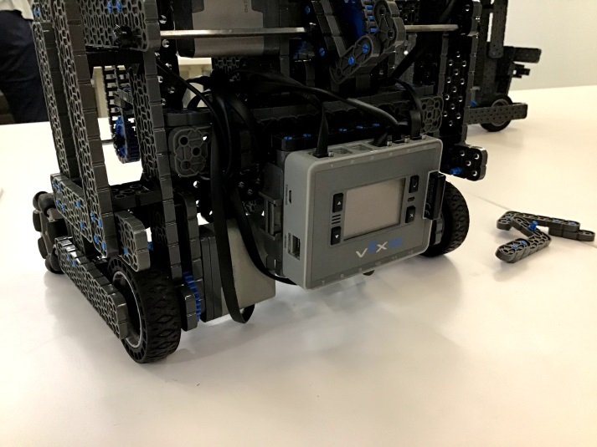 | 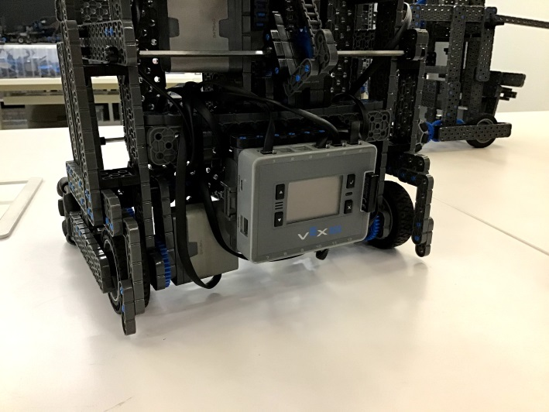

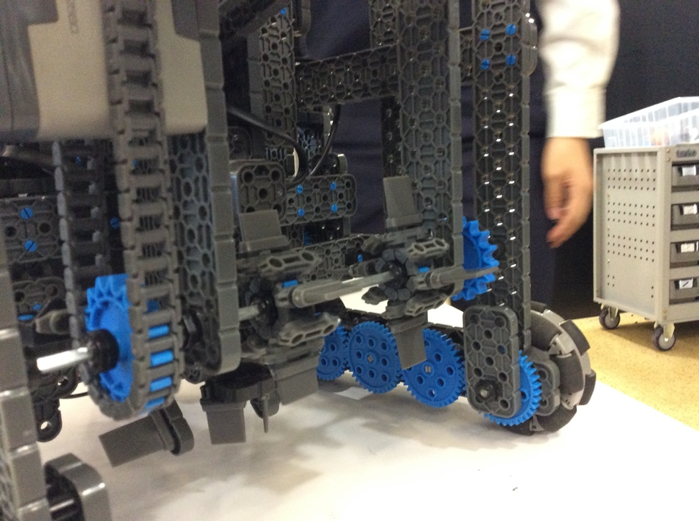
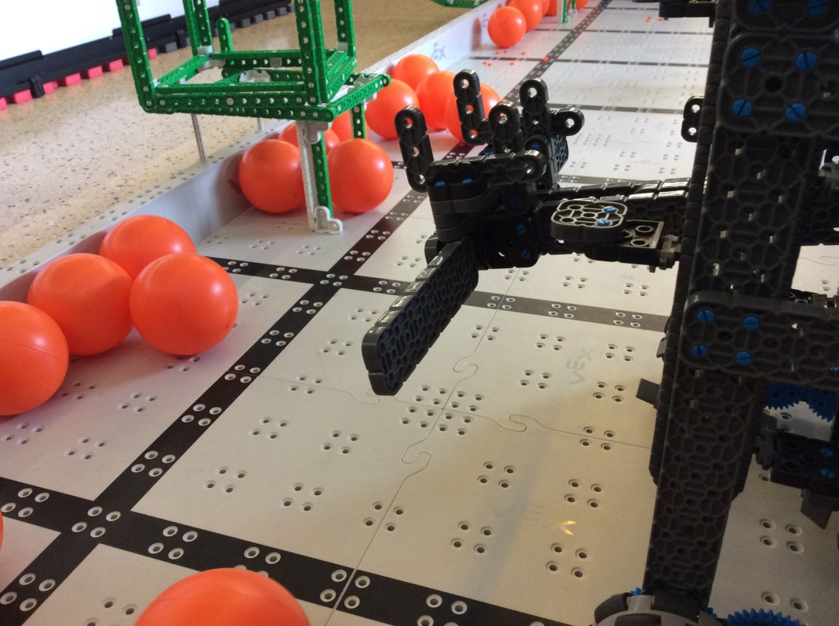
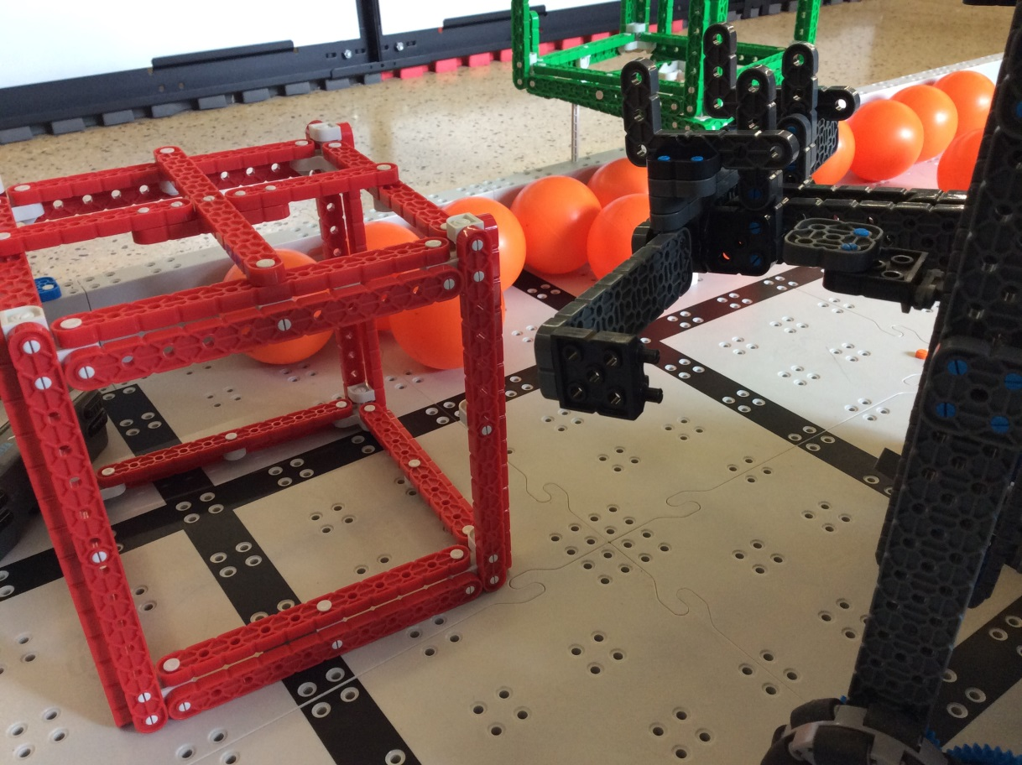
在先前的設計中，吸球時，因為吸嘴設在兩旁，所以只有兩旁的球會被吸進，而中間的球就會得排赤出去，導致吸球效率不佳．
所以我們在中間裝了個功能相似的吸嘴，這樣一來中間的球就不會被忽略．
如圖的修正是為了不讓cube的邊框卡進裡面，導致卡住後cube無法出去。

戰術策略 Tactics

我們的機器人：
- 抬上第二層的Cube (Y)
- 抬上第一層的Cube (Y)
- 一次抬兩顆Cube (Y)
- 車輪齒輪加速 (Y)
- 球放到cube上 (Y)
再來我們會依據隊友的機器來安排我們的戰術
(發出一份問卷調查)

單人賽(Skill Challenge)
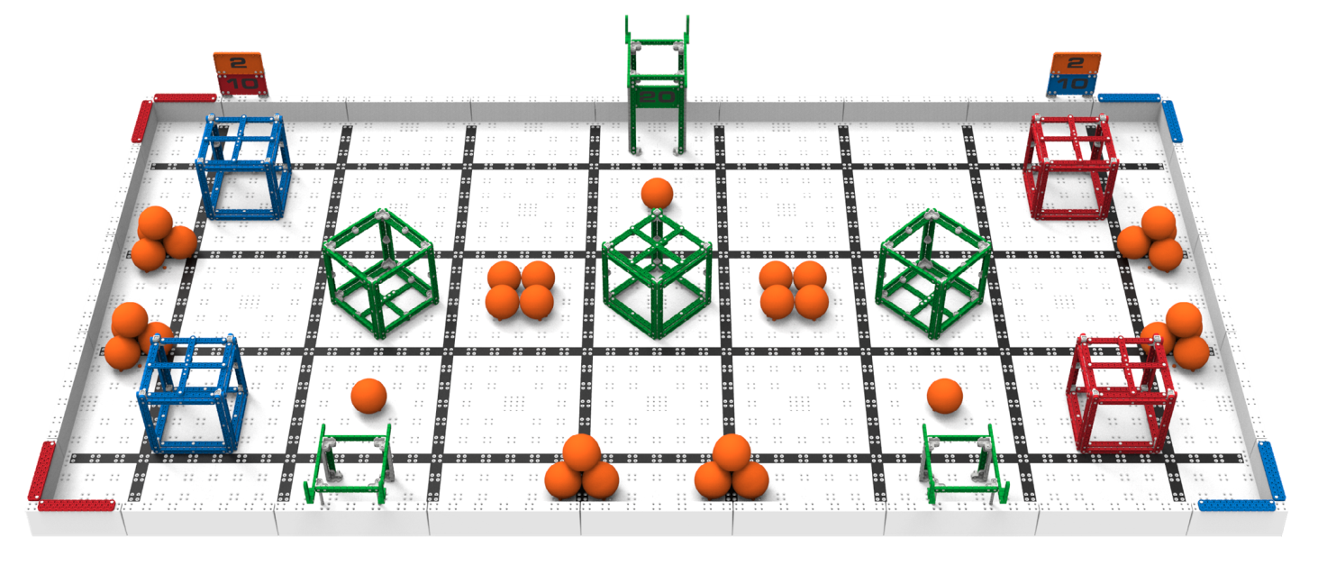
把全部的Cube 都歸位(100分)

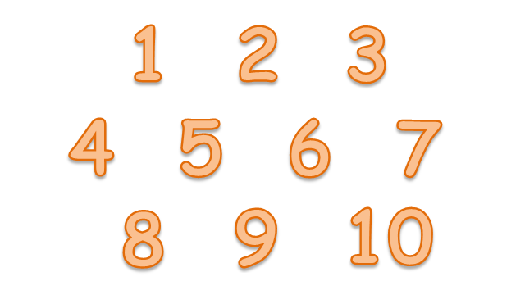

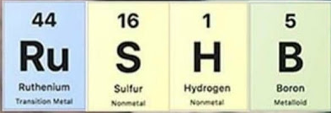
Ultimate tactic:441615

戰術策略 Tactics

左 Y(可) 右N(不可)
Q1: 抬上第二層的Cube
其中有兩個不合理的地方:
- 如果他可以Q1(抬到第二層), 又不能Q2(抬到第一層)。所以Y, N之後的都不合理
- 參加世界賽的機器不可能甚麼都不能做
Q2: 抬上第一層的Cube
Q3: 一次抬兩顆Cube
Q4: 車輪齒輪加速
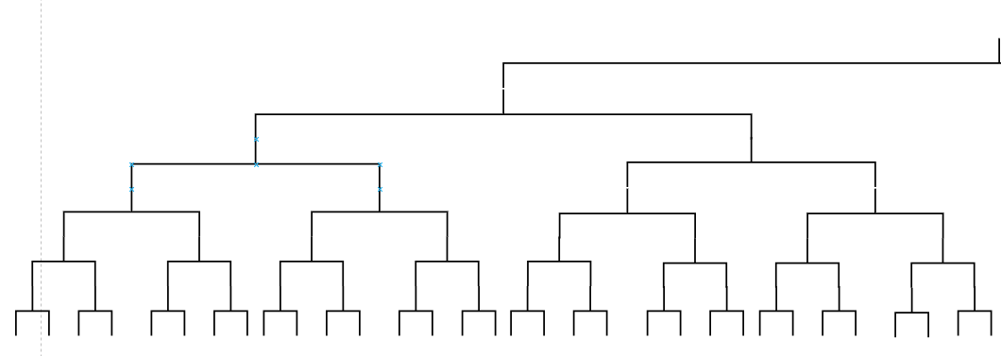
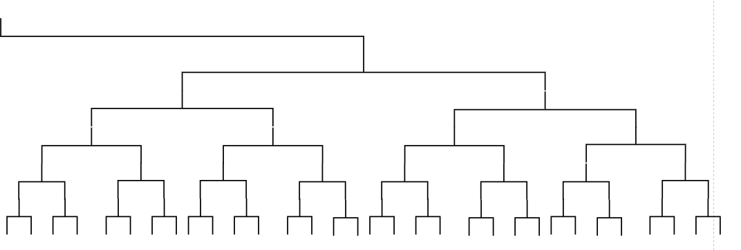
Q5: 球放到cube上
戰24
戰23
戰22
戰21
戰20
戰19
戰18
戰16
戰17
戰15
戰14
戰12
戰11
戰13
戰10
戰9
戰8
戰7
戰6
戰5
戰4
戰3
戰2
戰1
Q5
Q5
Q5
Q5
Q5
Q5
Q5
Q5
Q4
Q4
Q4
Q4
Q5
Q5
Q5
Q5
Q5
Q5
Q5
Q5
Q4
Q4
Q4
Q3
Q3
Q3
Q2
Q3
Q4
Q2
Q1
Q1
N
Y

